Organisation Name

Lawful Data – Workbook

Date of assessment:
Completed By:

This template accompanies our “Lawful Data - A guide for small and new UK charities to help you process data lawfully” guidebook. It is intended as a starter to help small charities work towards compliance with the GDPR and Data Protection Act. The information in these tables is drawn from our experience and will need to be completed for your particular circumstances: you will not be able to use this as-is. If you have any questions, please drop us a line at enquiries@lamplightdb.co.uk.
As a reminder, you’ll need your completed “Data Map” workbook (part one of the guide) and for each section, identify a lawful basis for processing that information. There are six possible bases. This workbook has template tables for the four most commonly used by charities.
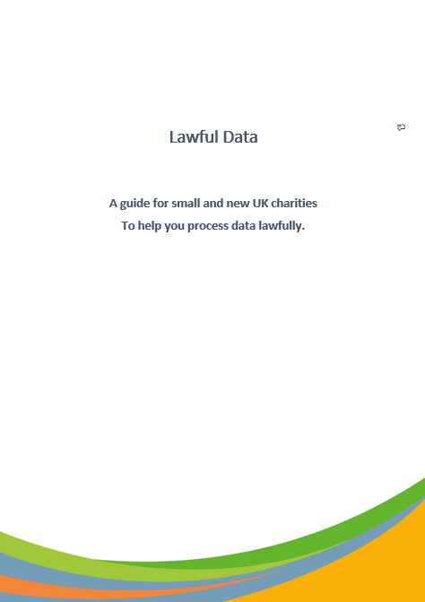
You’ll need to copy the relevant table and complete it for each section of the Data Map.
Consult the guide for full help, and there is also a wealth of detailed information, including helpful checklists, available on the Information Commissioner’s Office website: www.ico.org.uk/

January 2023

Disclaimer: This workbook and the accompanying guides do not constitute legal advice and are not a substitute for your duty to meet your own data protection obligations. These resources are designed as a starting point to assist small and new UK charities in thinking about their legal obligations and practical data needs and are used at your own risk. You should seek advice from a lawyer or data protection professional for further assistance.

Legal Obligation
 |  | Notes
Data Identifier  (Who is it about) |  | e.g. ‘Trustee Basic Information’. This should relate to the data map you’ve already completed.
Data Category  (What data about those people?) |  | Description of data, relate to the data map workbook.
Is this data about children or other vulnerable people? | Yes  No
Is any of this data particularly sensitive? | Yes  No | e.g. Health data, criminal records
What is the legal obligation that requires us to process this data? |  | Specify the law that applies.  Does not include contractual reasons.
Could we comply with the obligation without processing this data? | Yes  No
How long do we need to keep it?
When will we next review this?

Other Notes

Consent
 |  | Notes
Data Identifier  (Who is it about) |  | e.g. ‘Donor Information’. This should relate to the data map you’ve already completed.
Data Category  (What data about those people?) |  | Description of data, relate to the data map workbook.
Is this the most appropriate basis for processing? | Yes  No
Is this data about children or other vulnerable people? | Yes  No
Do we have age-verification/ parental consent measures in place for children? | Yes  No
Is any of this data particularly sensitive? | Yes  No | e.g. Health data, criminal records
How to we collect, record and maintain consent?
Is consent opt-in? | Yes  No
Where do we need to explain what they are consenting to?
Have we explained that they can withdraw their consent at any time? | Yes  No
What are the consequences if consent is withdraw?
How long do we need to keep it?
When will we next review this?

Other Notes

Legitimate Interest
 |  | Notes
Data Identifier  (Who is it about) |  | e.g. ‘Beneficiary Information’. This should relate to the data map you’ve already completed.
Data Category  (What data about those people?) |  | Description of data, relate to the data map workbook.
Is this the most appropriate basis for processing? | Yes  No
Is this data about children or other vulnerable people? | Yes  No
Is any of this data particularly sensitive? | Yes  No | e.g. Health data, criminal records
What’s the benefit to using this data? Who benefits? How big are the benefits?

Is this the best way to achieve these benefits? Is it proportionate?

On balance, do the benefits outweigh the negatives of collecting and processing this data? Would the data subject be OK with this? Can we explain it to them?
Can we offer an opt out for this? | Yes  No
Where do we give information about our legitimate interests?
How long do we need to keep it?
When will we next review this?

Other Notes

Contract
 |  | Notes
Data Identifier  (Who is it about) |  | e.g. ‘Service Purchasers’. These should relate to the data map you’ve already completed.
Data Category
(What data about those people?)
Is this data about children or other vulnerable people? | Yes  No
Is any of this data particularly sensitive | Yes  No | Health data, criminal records
What’s the contract?

Is the processing necessary for the performance of the contract? |  | Note that contracts with funders or others won’t provide a basis here – the contract has to be with the Data Subject.
How long do we need to keep it?
When will we next review this?

Other Notes

