Organisation Name

Data Map – What Do We Need And Why?

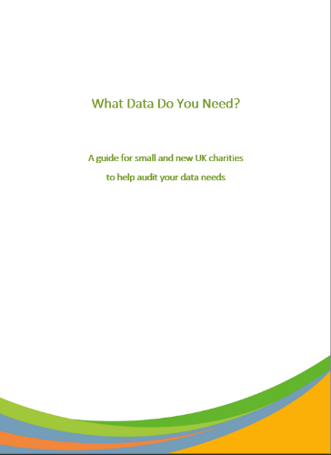
Date:
Completed by:

This template accompanies our “What Data Do We Need? A guide for small and new UK charities to help audit your data needs”. It is intended as a starter to help work towards compliance with the GDPR and Data Protection Act. The information in these tables is drawn from our experience and will need to be completed for your particular circumstances: you will not be able to use this as-is. If you have any questions please drop us a line at enquiries@lamplightdb.co.uk. As a reminder, you need to identify:
- Who is the data about? Complete a table for each different type of person (trustee, volunteer, donor, beneficiary etc)
- What data do you need about them? In the first column, note the different categories of data (e.g. contact, demographics, HR etc)
- Why do you need it? You don’t want to be a custodian of data you don’t need, and you need a justification for gathering it.
- Who needs access? Can it be accessible to anyone? Anyone in your organisation? Or does it need to be more restricted?
- What will you do with it? Will it be published as a case study? Summarised in a report? Shared with others?
In this workbook there’s a table for each of the common ‘who’ answers for small charities, and an example in the first row. Go through and fill it in with your own responses, and check the guide if you need more help. There is a blank table to copy and paste if you need to add more types of people.
Feel free to write notes for each section or next actions below each table, such as how long you will retain the data for, or when you will review your policies. There is more on that in the second guide our data protection series “Lawful data: A guide for small and new UK charities”.
There is also a wealth of detailed information available on the Information Commissioner’s Office website: www.ico.org.uk/

Who is it about: Trustees
What data about those people? | Why do you need it? | Who needs to access it? | What will you do with it?
Contact details | Organisation management | Any Internal  Public (partly) | Internal communications

Who is it about: Beneficiaries
What data about those people? | Why do you need it? | Who needs to access it? | What will you do with it?
Personal information (health / education / criminal record / …) | Provision of services | Limited Internal | Ensure services appropriate.  Aggregated reporting.  Individual reporting.  Information Sharing with Partners - Safeguarding.

Who is it about: Connected People
What data about those people? | Why do you need it? | Who needs to access it? | What will you do with it?
Contact details | Provision of services | Limited Internal | Emergency contact for beneficiary.  Information Sharing with Partners - Safeguarding.

Who is it about: Volunteers
What data about those people? | Why do you need it? | Who needs to access it? | What will you do with it?
DBS Check & related | Safeguarding | Limited Internal | Manage safeguarding within organisation

Who is it about: Staff
What data about those people? | Why do you need it? | Who needs to access it? | What will you do with it?
Job Application inc CV | Employment relationship | Limited Internal | Staff recruitment & management

Who is it about: Supporters
What data about those people? | Why do you need it? | Who needs to access it? | What will you do with it?
Nature of support | Fundraising | Limited Internal | Ensure appropriate information is provided

Who is it about: Donors
What data about those people? | Why do you need it? | Who needs to access it? | What will you do with it?
Financial information inc Gift Aid | Fundraising | Limited Internal | Financial Management

Who is it about: Partners
What data about those people? | Why do you need it? | Who needs to access it? | What will you do with it?
Services provided | Organisation management | Any Internal | Provide information to beneficiaries.

Who is it about: Suppliers
What data about those people? | Why do you need it? | Who needs to access it? |  | What will you do with it?
Contact details | Organisation management |  | Any Internal | Request services

Who is it about: <more here>
What data about those people? | Why do you need it? | Who needs to access it? |  | What will you do with it?

January 2023

Disclaimer: This workbook and the accompanying guides do not constitute legal advice and are not a substitute for your duty to meet your own data protection obligations. These resources are designed as a starting point to assist small and new UK charities in thinking about their legal obligations and practical data needs and are used at your own risk. You should seek advice from a lawyer or data protection professional for further assistance.

